Bug_01:
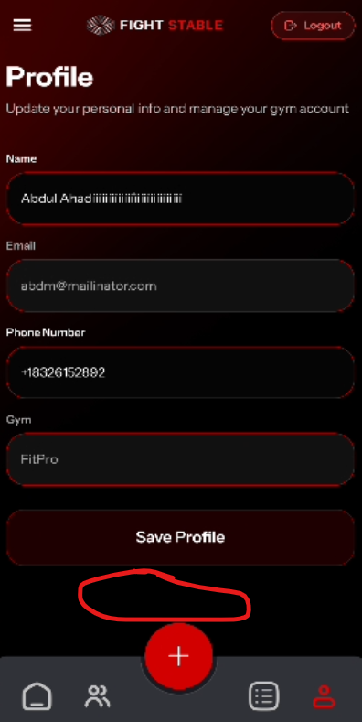
There should be Cancel Changes like button
Bug_02:
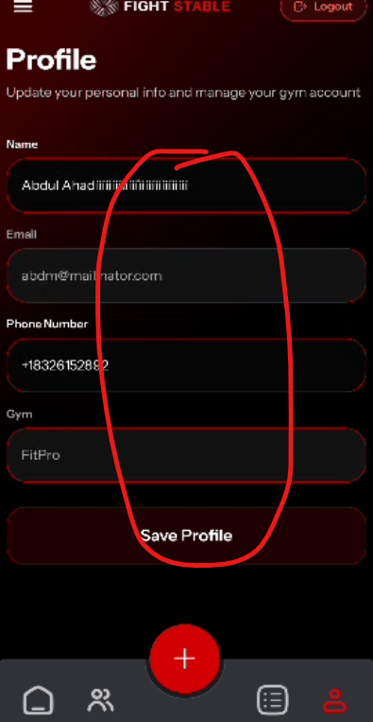
Usability Issue
User exactly don’t know which field can be edit or not.
Bug_03:
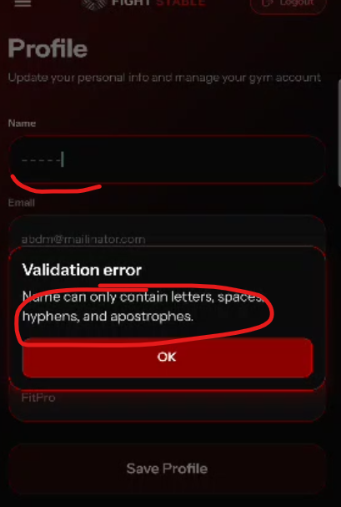
Incorrect validation error message
Bug_04:
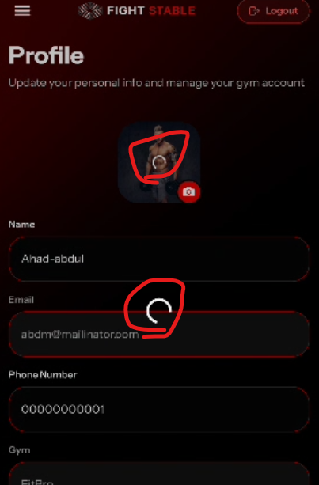
Dual loading sign when user changes its profile pic

Bug_05:
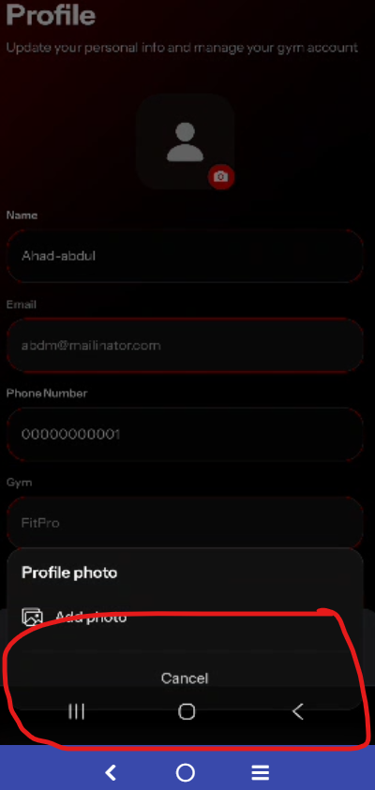
Overlap with bottom buttons

Bug_06:
Before logging out, it should ask do you want to logout ?

Bug_07:
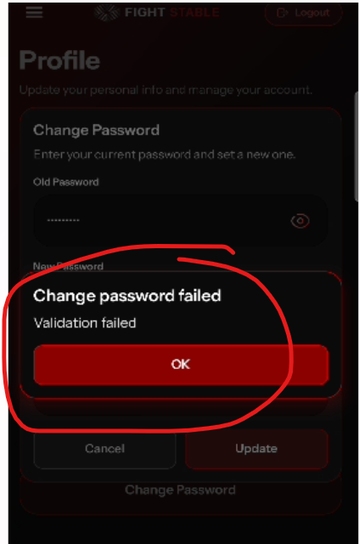
Incorrect error message when try to change password and put wrong old password

Bug_08:
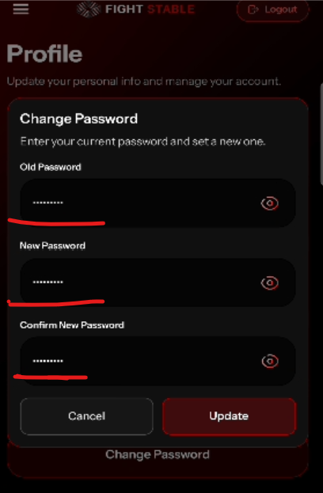
No error message appear below the fields

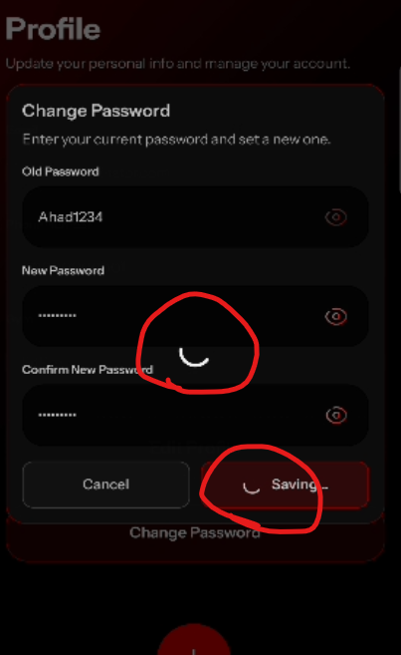
Dual loader

